
Program :B.tech(CSE)
Specialization :AIML
Course Title :AI Assisted Coding
Course Code :24CS002PC215
Semester :3rd semester
Academic Session :2025-2026
Name of Student :Bachanagari Deekshitha
Enrollment No. :2403A52032
Batch No. :02
Date :28/10/2025
#LAB ASSIGNMENT-13.3
#TASK DESCRIPTION-1:
Remove Repetition
Task: Provide AI with the following redundant code and ask it to refactor

Python Code
def calculate_area(shape, x, y=0):
if shape == "rectangle":
return x * y
elif shape == "square":
return x * x
elif shape == "circle":
return 3.14 * x * x

#PROMPT:
Refactor the following Python code to remove repetition and make it cleaner and more efficient:
def calculate_area(shape, x, y=0):
if shape == "rectangle":
return x * y
elif shape == "square":
return x * x
elif shape == "circle"
return 3.14 * x * x
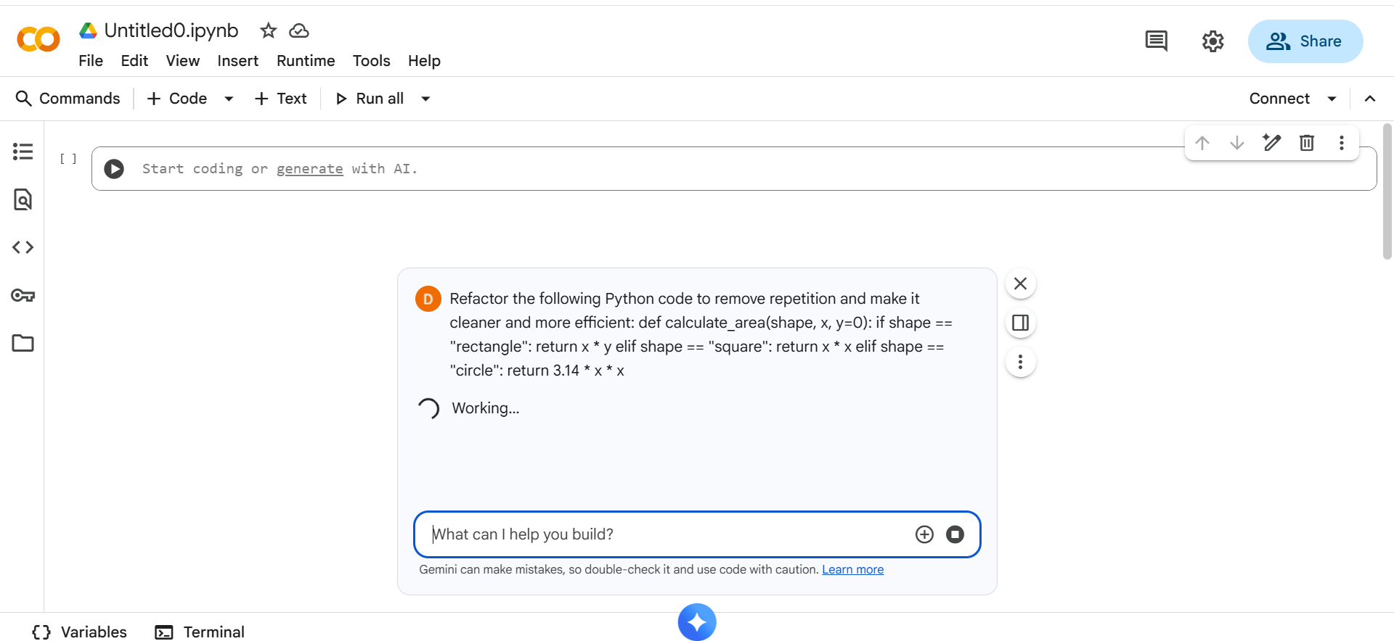
#CODE:
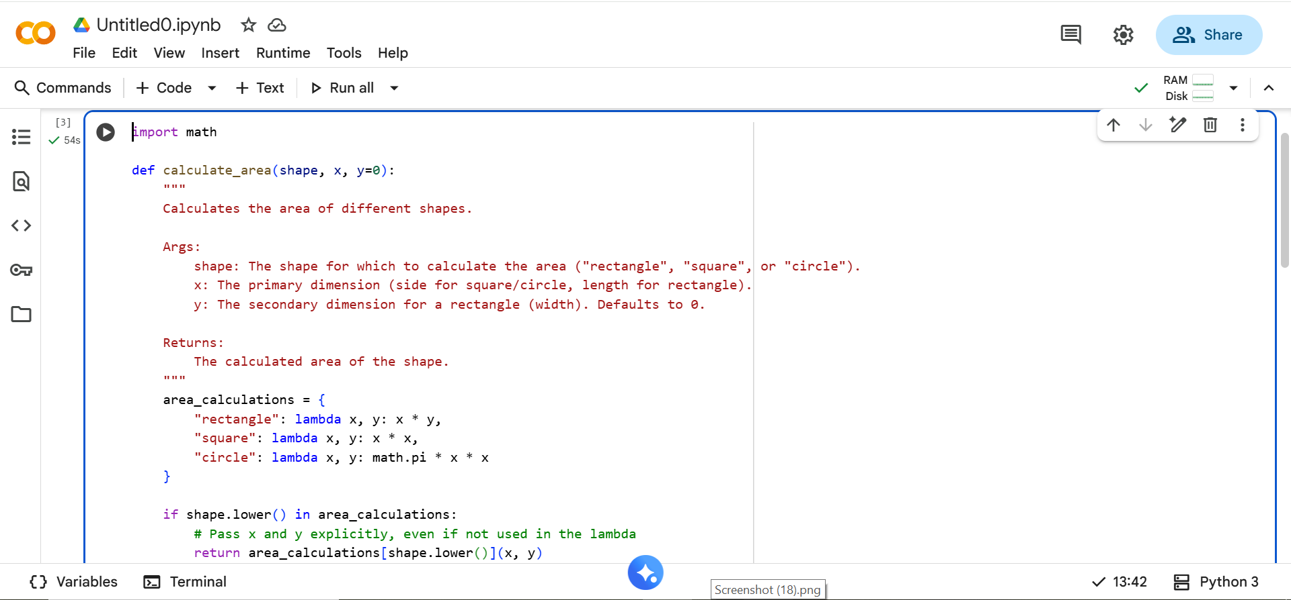
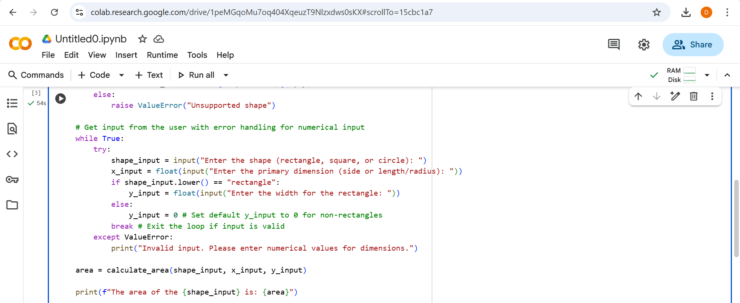
# OUTPUT:
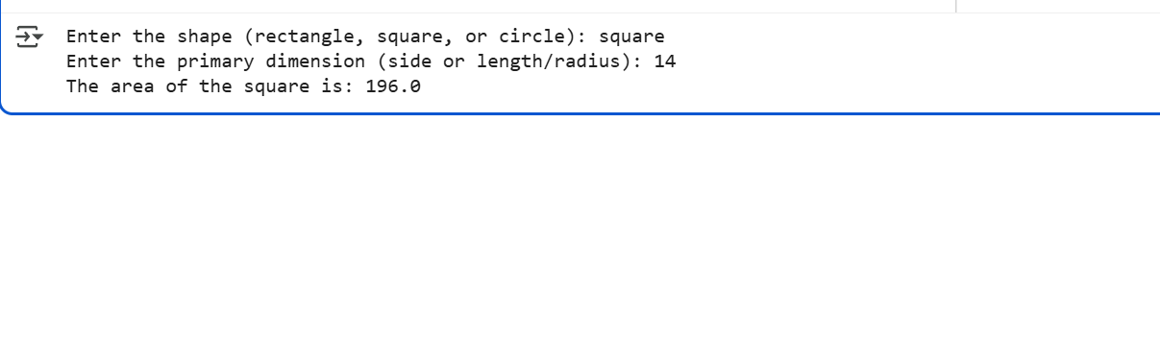
#TASK DESCRIPTION-2:
Error Handling in Legacy Code
Task: Legacy function without proper error handling

Python Code
def read_file(filename):
f = open(filename, "r")
data = f.read()
f.close()
return data
#PROMPT
Refactor the following code to use with open() and add try-except for proper error handling:

def read_file(filename):
f = open(filename, "r")
data = f.read()
f.close()
return data
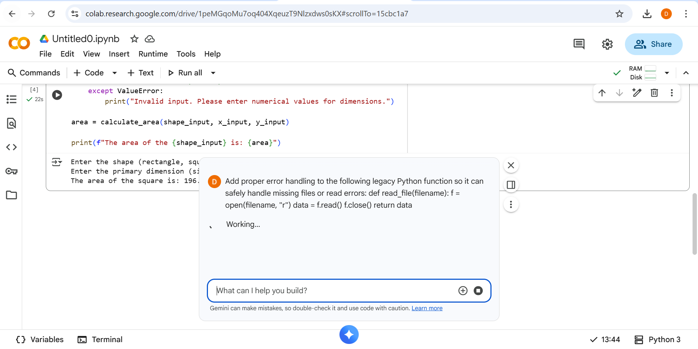

#CODE:

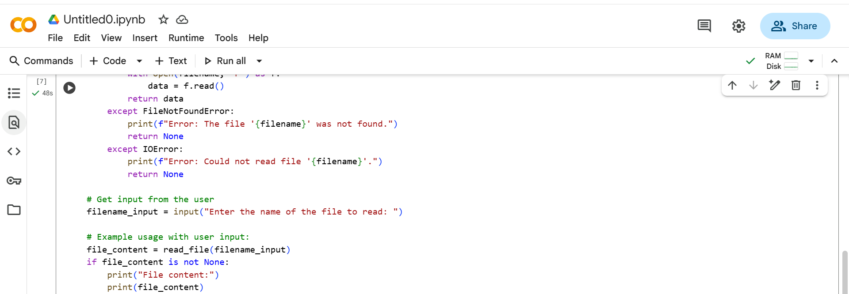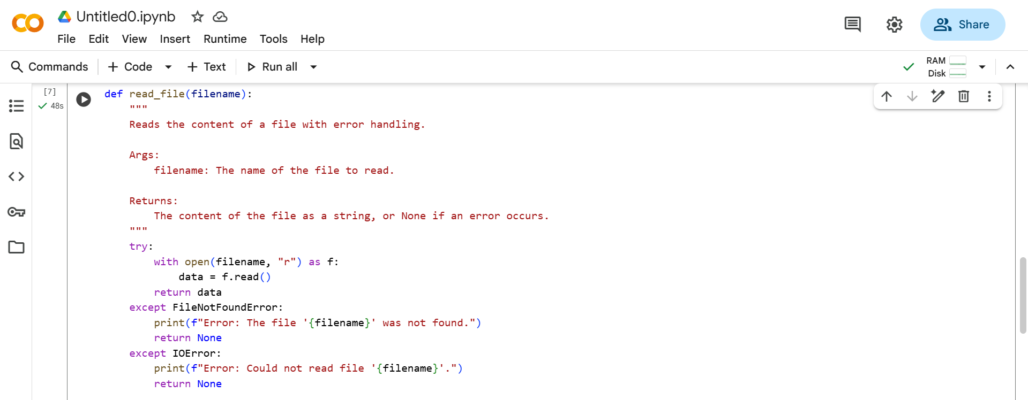

#OUTPUT:
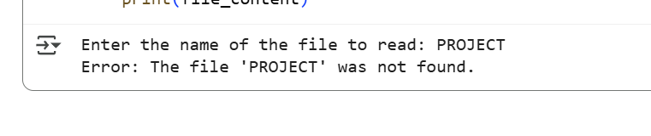
#TASK DESCRIPTION-3:
– Complex Refactoring
Task: Provide this legacy class to AI for readability and modularity improvements:
Python Code
class Student:
def __init__(self, n, a, m1, m2, m3):
self.n = n
self.a = a
self.m1 = m1
self.m2 = m2
self.m3 = m3
def details(self):
print("Name:", self.n, "Age:", self.a)
def total(self):
return self.m1+self.m2+self.m3
#PROMPT:
Refactor the following legacy Python class to improve readability and make the code more modular and well-structured:
class Student:
def __init__(self, n, a, m1, m2, m3):
self.n = n
self.a = a
self.m1 = m1
self.m2 = m2
self.m3 = m3

def details(self):
print("Name:", self.n, "Age:", self.a)

def total(self):
return self.m1 + self.m2 + self.m3
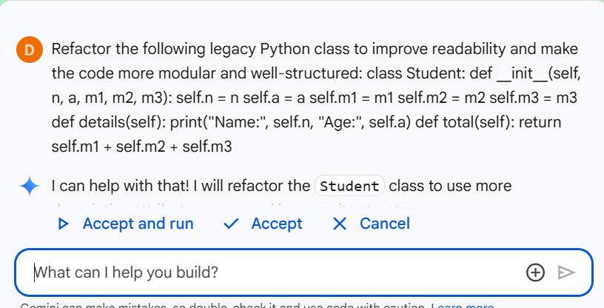
#CODE:
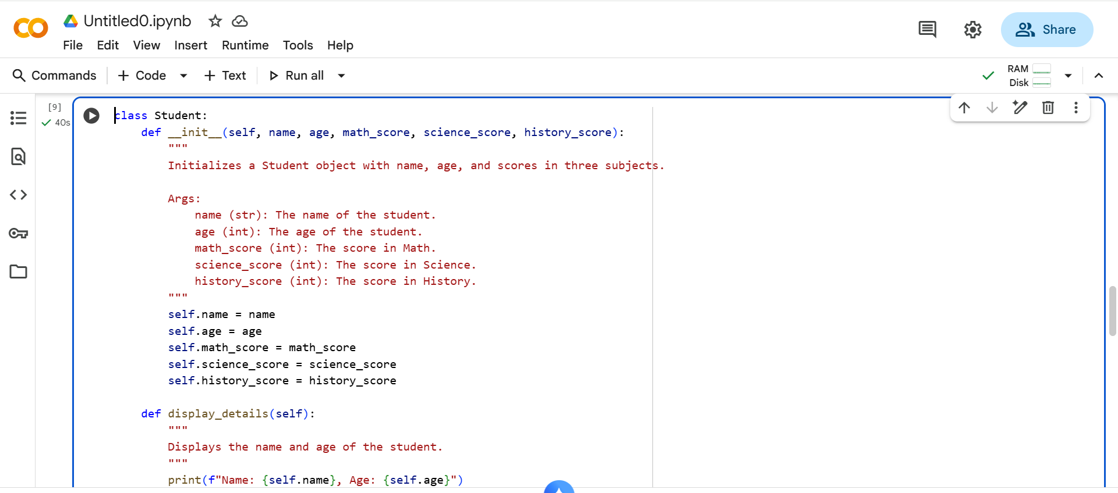
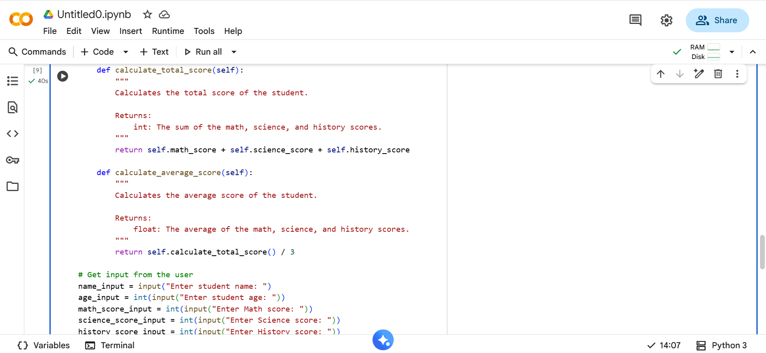
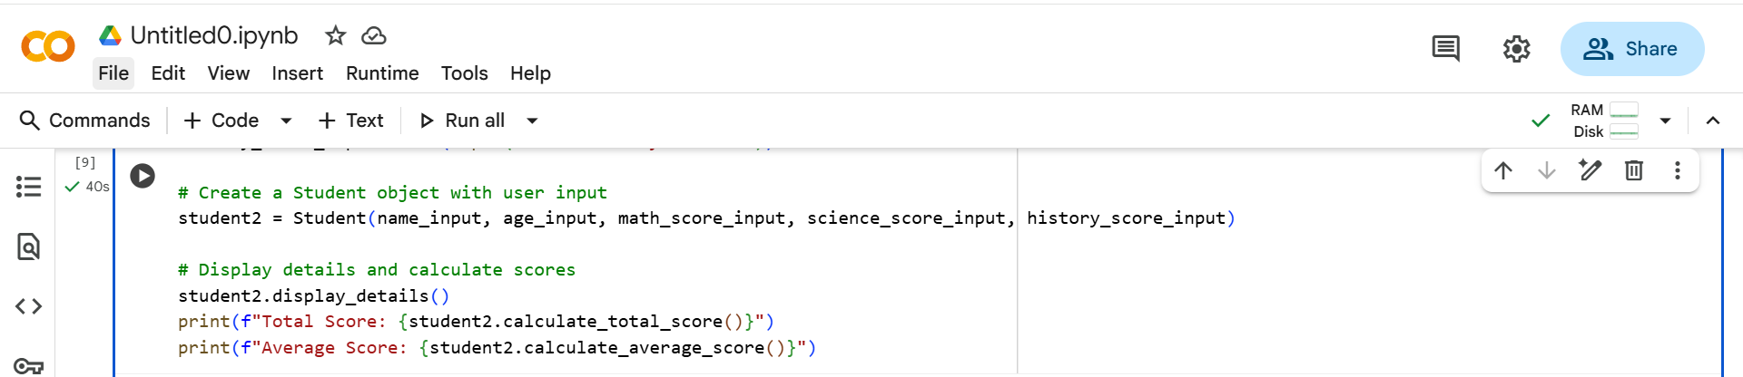
#OUTPUT:
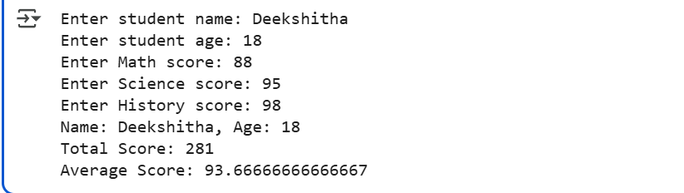
# TASK DISCRIPTION-4:
Inefficient Loop Refactoring
Task: Refactor this inefficient loop with AI help
Python Code
nums = [1,2,3,4,5,6,7,8,9,10]
squares = []
for i in nums:
squares.append(i * i)
#PROMPT:
Refactor the following inefficient loop to make it more concise and Pythonic:
nums = [1, 2, 3, 4, 5, 6, 7, 8, 9, 10]
squares = []
for i in nums:
squares.append(i * i)
#CODE:
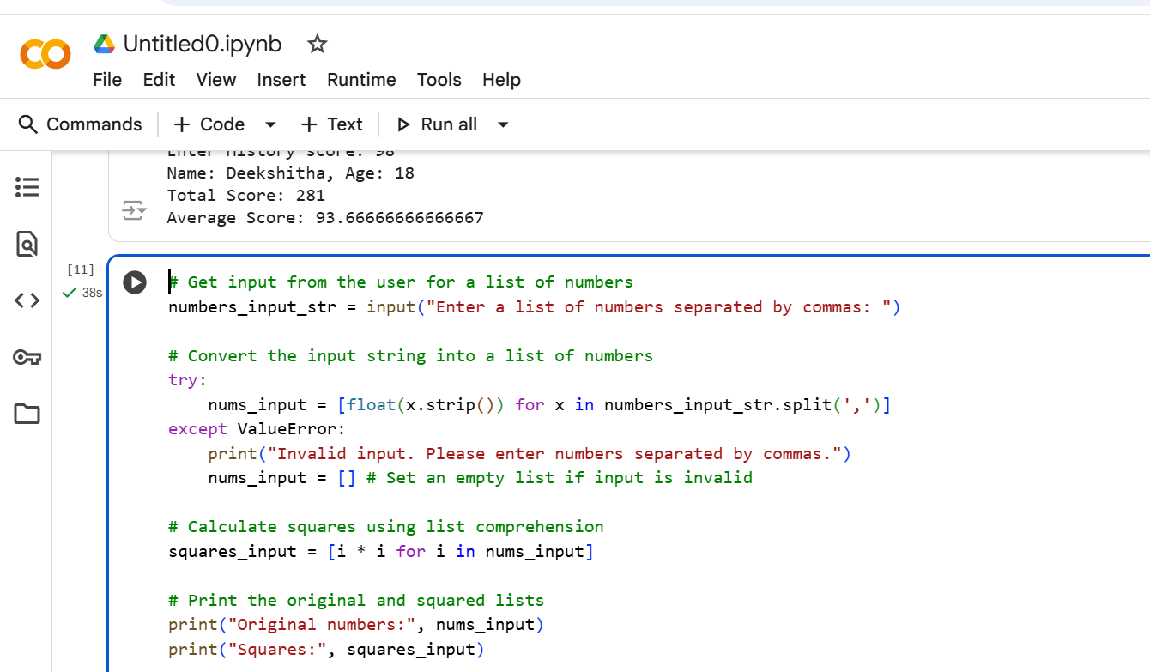
#OUTPUT:
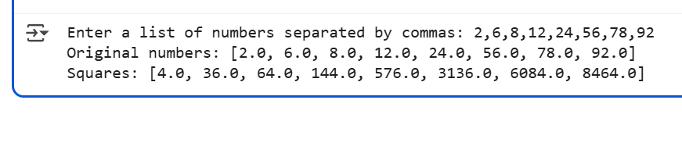
Thank You

